Curriculum Vitae
Personal information
Surname(s) | Lelichenko
First name(s) | Denys
Work Address(es) | N/A
Home Address(es)¹ | 36 Vozduhophlotskiy st., fl.13, 03186, Kiev, Ukraine
Work Telephone(s) |  | +380930223235, |  | Viber +380930223235
Travel Telephone (s)² |  | +37259641633
Skype ² |  | lelichenko_denis
Work E-mail(s) |  | denis7420@gmail.com
Nationality |  | Ukraine
Place of birth |  | Kiev, Ukraine.
Date of birth (dd/mm/yyyy) |  | 02.Mar.1983
Gender |  | Male
Identity card or passport or traveldocument |  | Number | ET 441648 |  | Issued by |  | Ministry of Justice
Date of issue and expire (dd/mm/yyyy) |  | Issued on | 11.Nov.2011 |  | Expires on |  | 11.Nov.2021
Work experience
Dates (mm/yyyy to mm/yyyy) |  | 06/2013 - till present.
Occupation or position held |  | Team Leader
Main activities and responsibilities |  | Armour guard of vessels in High Risk Area. (GoA/BEM/IRTS/SRS/ArSea/IndOcean)
Name and address of employer |  | “Bowline Defence Limited”, 58 Grosvenor Street, London W1K3JB.
Type of business or sector |  | Maritime security.
Dates (mm/yyyy to mm/yyyy) |  | 02/2012 to 06/2013
Occupation or position held |  | Team Leader
Main activities and responsibilities |  | Armour guard of vessels in High Risk Area. (GoA/BEM/IRTS/SRS/ArSea/IndOcean)
Name and address of employer |  | “SeaGuard Security LLC”, Key Biscayne, USA FL 33149.
Type of business or sector |  | Maritime security.
Dates (mm/yyyy to mm/yyyy) |  | 08/2008 to 02/2012
Occupation or position held |  | Security Company Commander. (Captain)
Main activities and responsibilities |  | Security and protection of Joint Staff of Armed Forces of Ukraine.
Name and address of employer |  | 101 Security Brigade. Ukraine.
Type of business or sector |  | Military. (Security and protection)
Dates (mm/yyyy to mm/yyyy) |  | 06/ 2007 to 08/2008
Occupation or position held |  | Commander of Airborne Company. (1-st. Lieutenant)
Main activities and responsibilities |  | Combative management of Airborne Company in combat.
Name and address of employer |  | 95-th Airborne Brigade. Ukraine.
Type of business or sector |  | Military.
Dates (mm/yyyy to mm/yyyy) |  | 12/ 2006 to 06/ 2007
Occupation or position held |  | Assistant Commander of Airborne Company. (Lieutenant)
Main activities and responsibilities |  | Teaching and training for jumps with parachute from different kinds of planes and helicopters.
Name and address of employer |  | 95-th Airborne Brigade. Ukraine.
Type of business or sector |  | Military.
Education and training
Dates (mm/yyyy to mm/yyyy) |  | 04/04/2015 to 08/04/2015
Title of qualification awarded |  | Marine Security Operative – Team Leader course.  Marine Security Operative – Anti Piracy course,
Principal subjects/occupational skills covered |  | Protection of vessels in deferent event . Management of team in deferent event. BDL Module: C – PAC - 01.03
Name and type of organisation providing education and training |  | Maritime Training Centre of Seafarers - “AVANT LCC”, Ukraine.
Level in national or international classification |  | International
Dates (mm/yyyy to mm/yyyy) |  | 05/01/2013 to 20/01/2013
Title of qualification awarded |  | STCW 78/95,  SSO (ship security officer)
Principal subjects/occupational skills covered |  | ISPS, Studied safety measures of vessels, safety measures and protection of the vessels being both in the high sea, and in ports. Fire fighting simulator.
Name and type of organisation providing education and training |  | Maritime Training Centre of Seafarers - “AVANT LCC”, Ukraine.
Level in national or international classification |  | International
Dates (mm/yyyy to mm/yyyy) |  | 02/2009 to 04/2009, (09/2007 to 11/2007)
Title of qualification awarded |  | Security and protection of Joint Staff of Armed Forces of Ukraine.
Principal subjects/occupational skills covered |  | Courses of Security and protection of Joint Staff of Armed Forces . Anti-terror for officers.
Name and type of organisation providing education and training |  | Academy of Armed Forces of Ukraine.
Level in national or international classification |  | Officer - specialist
Dates (mm/yyyy to mm/yyyy) |  | 05/2006 to 12/2006
Title of qualification awarded |  | Officer – Translator
Principal subjects/occupational skills covered |  | Courses of English language for officers of armies of a special purpose.
Name and type of organisation providing education and training |  | Military base “MEGA” Sen Jean Sju Reshele, Québec, Canada.
Level in national or international classification |  | Officer – Translator
Personal skills and competences
Language skills |  | Specify your mother tongue(s) and the other languages you are able to understand, speak or write.
Mother tongue(s) |  | Ukraine, Russian.
Other language(s) |  | English.
Language Self-assessment  (in accordance with the Common European Framework of Reference for Languages)
   | Understanding |  | Speaking
  Language | Listening | Reading | Spoken interaction | Spoken production | Writing
  Ukraine | C2 class | C2 class | C2 class | C2 class | C2 class
  Russian | C2 class | C2 class | C2 class | C2 class | C2 class
  English | B2 class | B2 class | B2 class | B2 class | B2 class
Other personal skills and competencies |  | Provide a description, where you consider it necessary of the skills and competences you have in the following areas and indicate where they were acquired.
Social skills and competences |  | Management of groups of people. Teaching and training of groups of people.
Organisational skills and competences |  | The organization and carrying out of various actions.
Technical skills and competences |  | Ability to work with map, GPS, drawing. Land and marine radar equipment. To develop drawings, maps. Good skills to use the Russian, Soviet and same NATO, weapons. Hand guns: PM-9,TT,APS, Fort-12, Glock-17. Sub-Machine: AKS-74U, Mp-5. Assault Rifle; M4/A1,AKM,AK-47/74/N,AKS-74. Machine Gun: RPK-74/S,PK/PKM,PKT,KPVT,2A42. Rocket Launcher: GP-25,AGS-17,RPG-7/18, PZRK.
Computer skills and competences |  | User. Microsoft office,
Other skills and competences |  | Excellent fire and physical preparation. Good skills of hand-to-hand fight. Experience of work with the VIPs. Readiness of departure in business trips. Ability analytically to think, to build schemas and to predict working processes. The developed intuition, mobility. Ability in short terms to find and come into necessary contacts and communications in the unfamiliar environment.  Responsible, steady against stresses, obligatory, punctual, sociable, executive, disciplined and easily to trained. Without bad habits. I am able to be self – controlled in extreme situations. I am able to work in group, to achieve objects in view, an active vital position, insistence, work on result. 52 jumps with parachute from different kinds of planes and helicopters..  Decency, Confidentiality and Professionalism, I am guarantee.
Places of residence |  | Provide information on the places where you have been living, for more than one month, during the last 10 years starting from the most recent.
Place | Country | From | To
Odessa | Ukraine | 2000 | 2004
Sen Jean Sju Reshele | Canada | 05/2006 | 12/2006
Kiev | Ukraine | 2006 | till present

Additional information |  | Seaman’s identification card: Ukraine, No AB 512948, date of issue 28.Jan.13, date of expiry 28.Jan.18.
Annexes |  | STCW No 3/AA/0050/0/13;  SSO No 3/BF/0005/0/13;  International certificate of vaccination against yellow fever : Egypt, date of issue 22.May.12, date of expiry 22.May.22.
Photograph |  | 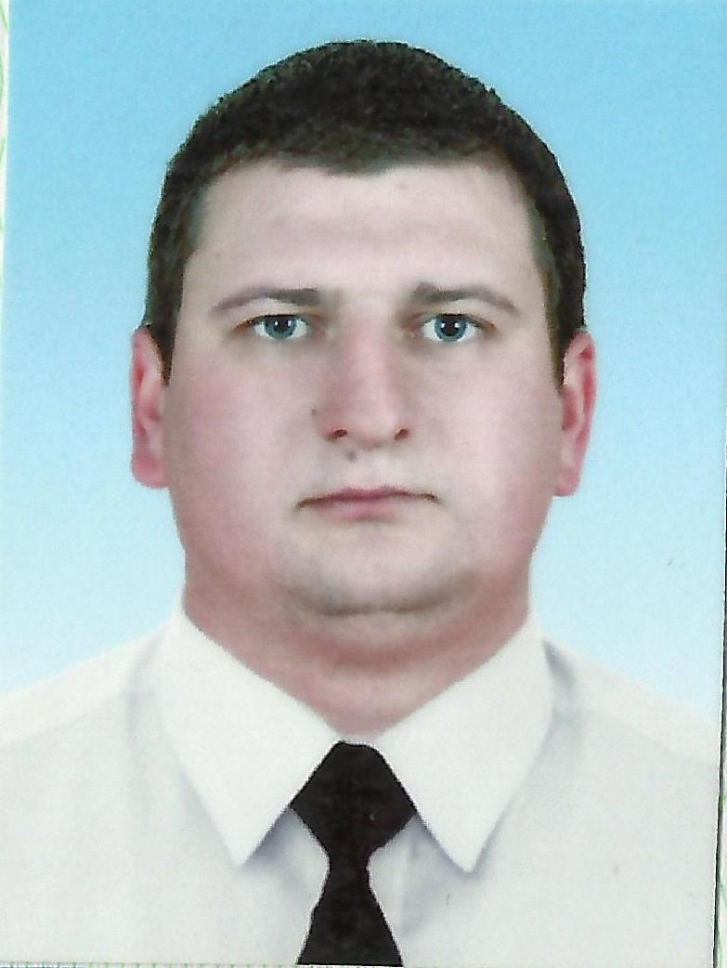

House number, street name, postcode, city, country, using the postal address format of the country concerned.
Country code - Area code – Number.
Add separate entries for each relevant post occupied, starting from the present one. In case you had more than five previous employments, you can copy and paste the entries below, to provide the further information you need.
The entries below should be used for provide information in relation to secondary, post-secondary (college), undergraduate and post graduate university education. Add separate entries for each relevant academic course or programme you have completed, starting from the most recent. In case you need to make entries more than the ones provided below, you can copy and paste the entries below, to provide the further information you need. Specialized professional training courses such as STCW basic training or ISPS Code security-related training should be given in a list (title of course, training establishments and dates of course) and the related certificates or testimonials should be attached.

